Project Initialization and Planning Phase
Problem  Statement  (PS) | I am  (Customer) | I’m trying  to | But | Because | Which makes me feel
PS-1 | A farmer growing crops | Choose the most suitable crop for my land | I don’t reliable date- driven guidence | I lack access to expert agricultureal advice | Uncertain and worried about crop yeild

Date | 15 July 2026
Team ID | SWTID-2026-1999
Project Name | OptiCrop: Smart Agricultural Production  Optimization Engine
Maximum Marks | 3 Marks

Define Problem Statements (Customer Problem Statement Template):
PS-2 | A small- scale farmer | Choose the most suitable crop for my land | I don’t which crop suits mu soil and weather conditions | I lack access to expert agricultural guidance | Uncertain and worried about crop yeild
Create a problem statement to understand your customer's point of view. The Customer Problem Statement template helps you focus on what matters to create experiences people will love. A well-articulated customer problem statement allows you and your team to find the ideal solution for your customers' challenges.
Throughout the process, you’ll also be able to empathize with your customers, which helps you better understand how they perceive your product or service.



Example:
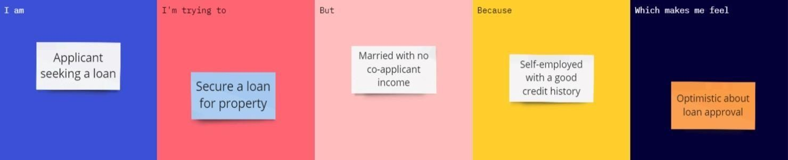

PS-3 | A farmer with limited resources | Maximize my harvest and income | I often pick crops based on guesswork or tradition | I have no data deiven tool to guide my decisions | Frustation and financially insecure

